Sprint 1 - Endurance Design Document

March 30, 2020

Jason Lyons, Chloe Joyce, and Reese Griffin

# **1.** **Executive Summary**

## **1.1** **Project Overview**

In this project, our group will program a robot, using block code from the app Sphero Edu, to circumnavigate itself in a rectangular shape around our classroom following the yellow tiles, ending at the same tile as it started. We intend for the rest of the class and Professor Eckert to be our audience.

## **1.2** **Purpose and Scope of this Specification**

In scope

Out of Scope Can’t test robot in classroom

* We aren’t able to test robot in the classroom

# 

# 

# **2.** **Product/Service Description**

## **2.1** **Product Context**

SpheroEdu can relate to other products of a similar type as the basis of the coding and algorithms given can be applied to other robotics projects as well, such as the general ideas of “turn 90 degrees” or “continue straight”. Not only this, but it can allow for students to build an understanding of robotics and what goes into programming and coding, which can help with building and designing other species of systems. The coding itself may be only fitted to the Sphero+ robot, however, and may require reworking in order to get them accustomed to other programs.

## **2.2** **User Characteristics**

Students: As students, we will be using the app Sphero Edu to create and produce this sprint. This program will allow us to create a code that will make the robot being used travel in a rectangle around our classroom almost perfectly, finishing in the same square tile as it started in.

## **2.3** **Assumptions**

The operating system is assumed to be available, the robot is assumed to be available, technology for the app being used is assumed to be available.

## **2.4** **Constraints**

Describe any items that will constrain the design options

* No access to the robot
* No access to technology
* No access to the space/area to run the program
* Not knowing exact dimensions/measurements of area being used for program

## **2.5** **Dependencies**

Dependencies that will affect the requirements:

* Must have a form of technology with bluetooth enabled to connect to the robot.
* Need a proper area to run the program (flat, large amount of space, nothing on floor).
* Must have a robot in general to run the program, Sphero+ being recommended specifically.
* Robot must be properly aligned, charged, and prepared for the run.

# **3.** **Requirements**

Requirements

1. We need a descriptive and informatized algorithm to help with the coding process.
2. The code needs to be precise and accurate so that the robot can finish in the same spot as it started.
3. The aim on the robot needs to be correct before running the program so that it can stay on target.
4. The floor being used as the course shouldn’t have any interfering objects in the way, as it could mess the robot’s path up.
5. Test with the robot with the final algorithm and make sure everything is correct.

## **3.1** **Functional Requirements**

|  |  |  |  |  |  |
| --- | --- | --- | --- | --- | --- |
| Req# | Requirement | Comments | Priority | Date Rvwd | SME Reviewed / Approved |
| ENDUR_01 | Descriptive algorithm | After a few tries, it is correct | 1 | 3/6 | Yes |
| ENDUR_02 | Accurate and precise code | Went over code multiple times with all 3 of us putting our input and prior knowledge into it | 2 | 3/6 | Yes |
| ENDUR_03 | Aim needs to be correct before testing | Use app to steer aim to make it go smoothly to corner 2 | 3 | 3/6 | Yes |
| ENDUR_04 | Make sure floor is cleared before testing | Not completely possible, as we aren’t in class | 4 | 3/29 | Yes |
| ENDUR_05 | Tested and correct program | Finished product of sprint 1 | 5 | 3/29 | Yes |

## **3.2** **Security**

### **3.2.1** **Protection**

· aim not being centered

· object on floor causing robot to go a different direction

· app Sphero Edu not working correctly

· robot not being charged

### **3.2.2** **Authorization and Authentication**

As for the authorization and authentication, to use Sphero Edu, you need to create a login to access the app. After making this login, you are then able to program and code with a robot that is connected via Bluetooth. Authentication can be relied heavily on sites like PubCookie. This site helps keep users on particular sites safe, keeping their information and other important things hidden from the public.

## **3.3** **Portability**

Portability of the code from the app Sphero Edu to the robot is necessary for this project to be complete.

# 

# **4.** **Requirements Confirmation/Stakeholder sign-off**

|  |  |  |
| --- | --- | --- |
| Meeting Date | Attendees (name and role) | Comments |
| 03/06/20 | Jason, Chloe, Reese | confirmed all except ENDUR_04 and ENDUR_05 |
| 03/29/20 (Online) | Jason, Chloe, Reese | Confirmed all |

# 

# 

# 

# 

# 

# 

# 

# **5.** **System Design**

## **5.1** **Algorithm**

* Start at yellow tile with blue tape.
* Turn green, and speak “Ready, set, go!”
* Roll to second corner
* Pause for 2 seconds, then turn 90 degrees
* Roll to third corner
* Pause for 2 seconds, then turn 90 degrees
* Roll back to starting corner
* Light turns red, speaks “I’m done and I need water.”
* End

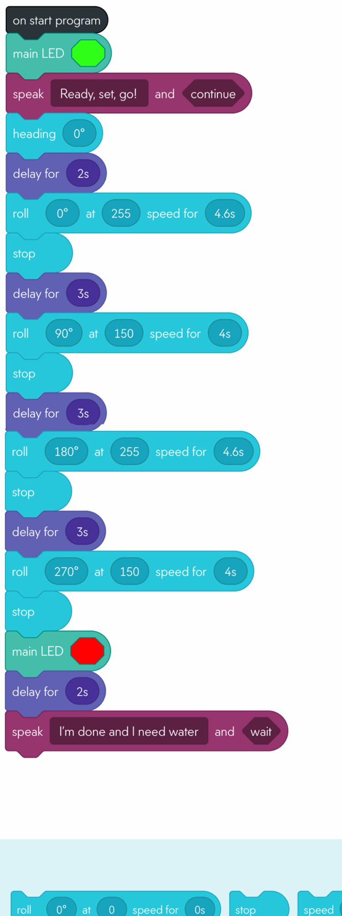

**5.2** **System Flow**

Develop a flowchart (and show here) that accurately depicts how your software application will act to fulfill the algorithm

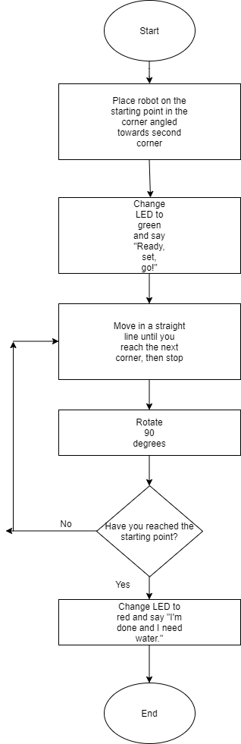

## **5.3** **Software**

The software platform that was used was Sphero Edu, and it was used to create the coding for this sprint.

## **5.4** **Hardware**

The hardware platform used to develop, test, and demonstrate this sprint was Sphero Edu. We used block coding through the app, which was connected to the robot to develop and test the algorithm.

## **5.5** **Test Plan**

|  |  |  |  |  |  |
| --- | --- | --- | --- | --- | --- |
| **Reason for Test Case** | **Test Date** | **Expected Output** | **Observed Output** | **Staff Name** | **Pass/Fail** |
| Algorithm | 3/15 | Correct algorithm | Didn’t turn correctly to go to next corner | Reese | Fail |
| Algorithm | 3/17 | “ “ | Aim wasn’t correct | Reese | Fail |
| Algorithm | 3/22 | “ “ | Didn’t finish at same spot | Reese | Fail |
| Algorithm | 3/26 | “ “ | Speed too fast, went way past corner 2 | Reese | Fail |
| Algorithm | 3/29 | “ “ | Correct algorithm | Reese | Pass |

## 

## 

## 

## **5.6** **Task List/Gantt Chart**

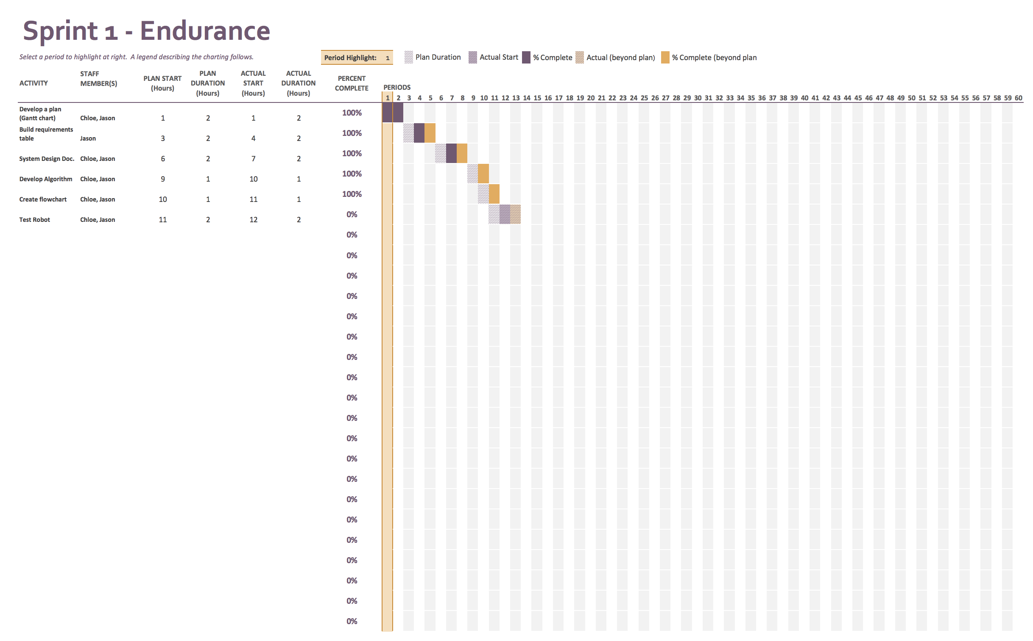

## **5.7** **Staffing Plan**

Table below depicts the roles and responsibilities of each team member.

|  |  |  |  |
| --- | --- | --- | --- |
| Name | Role | Responsibility | Reports To |
| Jason Lyons | System design document | Complete document fully with correct information | Everyone |
| Chloe Joyce | System design document | Complete document fully with correct information | Everyone |
| Reese Griffin | Has robot, test algorithms | Make algorithm and test | Everyone |